**WEB PROGRAMING PRACTICUM REPORT**

**MODULE 9**

**SESSION**



**CREATED BY :**

**KURNIAWAN BAGASKARA**

**L200214253**

**INFORMATICS STUDY PROGRAM**

**FACULTY OF COMMUNICATION AND INFORMATION SCIENCE**

**MUHAMMADIYAH SURAKARTA UNIVERSITY**

**PRACTICE**

Counter

<?php

    session_start();

    error_reporting(E_ALL^E_NOTICE);

?>

<html>

    <head>

        <title>Mengakses Data Session</title>

    </head>

    <body>

        <?php

            $_SESSION['counter']++;

            $_SESSION['nama_pengunjung']="Adul";

            echo "Selamat Datang ".$_SESSION['nama_pengunjung']."<br>";

            echo "Anda telah mengunjungi halam ini sebanyak ".$_SESSION['counter']." kali.";

        ?>

    </body>

</html>

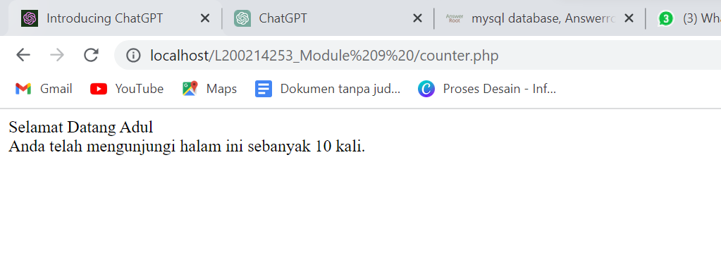

Destroy

<?php

    session_start();

    $id_session=session_id();

    echo "Session ID anda adalah ".$id_session;

    echo "<br><br>";

    session_destroy();

    $id_session2=session_id();

    echo "Session ID anda setelah data session di-destroy : ".$id_session2;

?>

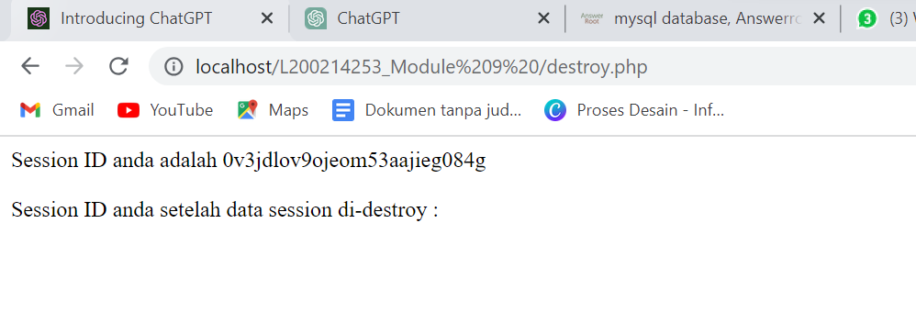

Login

<?php

    session_start();

    error_reporting(0);

    $koneksi = mysqli_connect('localhost','root','','informatika2');

    $username=$_POST['username'];

    $password=$_POST['password'];

    $submit=$_POST['submit'];

    if($submit){

        $sql="select * from user where Username='$username' and Password='$password'";

        $query=mysqli_query($koneksi,$sql);

        $row=mysqli_fetch_array($query);

        if($row['username']!=""){

            //berhasil login

            $_SESSION['username']=$row['username'];

            $_SESSION['status']=$row['status'];

            echo "<script>

                        alert('Anda Berhasil Login Sebagai $row[username]');

                        document.location='hasillogin.php';

                  </script>

                ";

        }else{

            echo "<script>

                    alert('Gagal Login');

                    document.location='login.php';

                  </script>";

        }

    }

?>

<form *method*='POST' *action*='login.php'>

    <p *align*='center'>

        Username : <input *type*="text" *name*="username" *id*="username"><br>

        Password : <input *type*="password" *name*="password" *id*="password"><br>

        <input *type*="submit" *value*="submit" *name*="submit">

    </p></form>

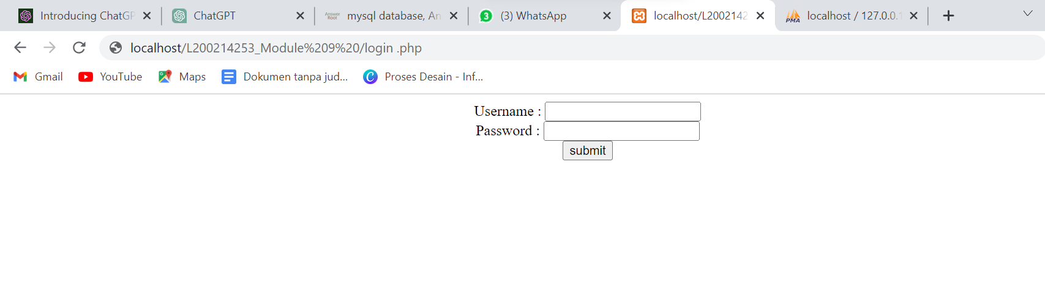

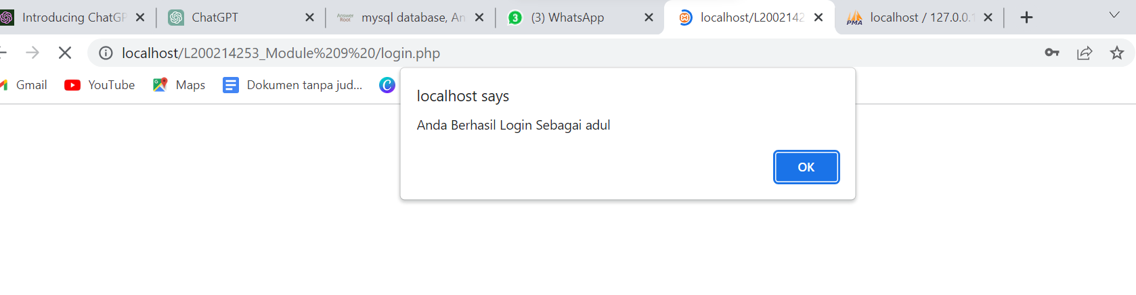

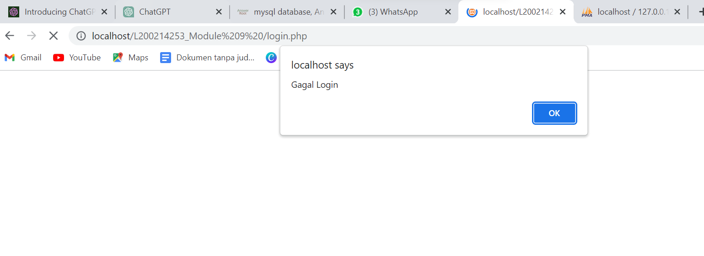

Hasillogin

<?php

    session_start();

    echo "Anda berhasil login sebagai ".$_SESSION['username'];

    echo " dan anda terdaftar sebagai ".$_SESSION['status'];

?>

<br>

Silahkan logout dengan klik link <a *href*="logout.php">Disini</a>

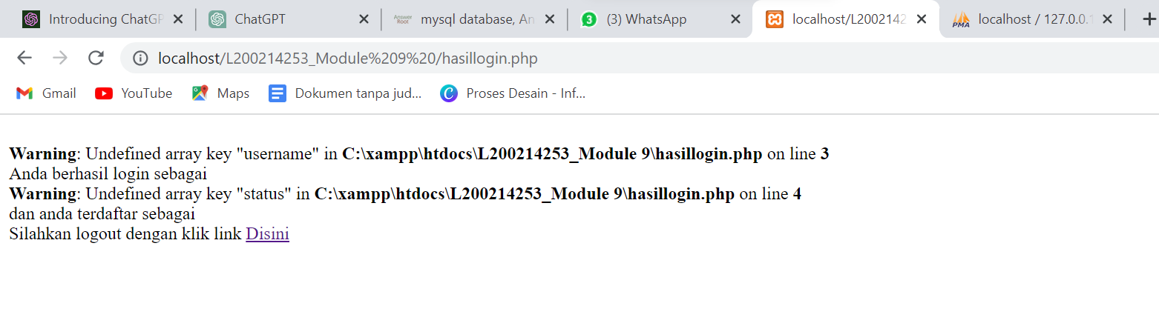

Logout

<?php

    session_start();

    session_destroy();

?>

<script *language*="Javascript">

    alert("Anda telah logout");

    document.location="login.php";

</script>

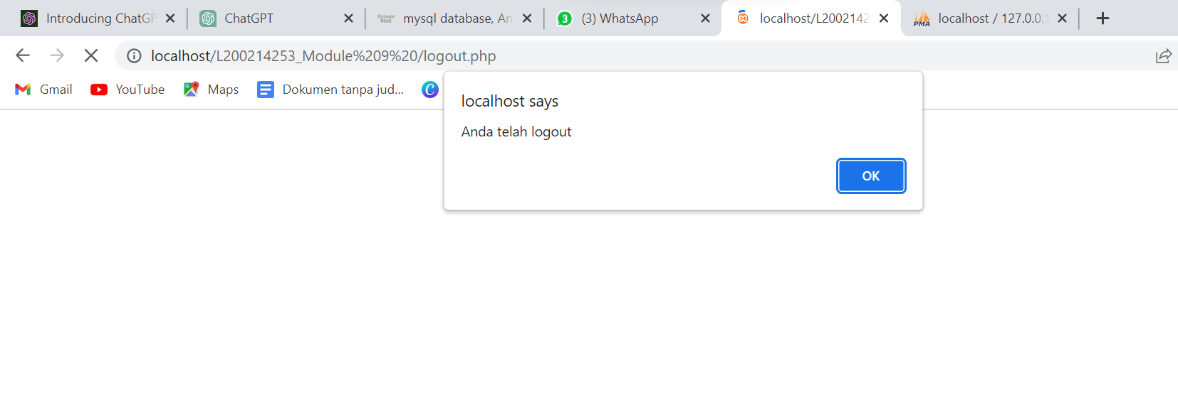

**TASK**

Tugas

<?php

    session_start();

    error_reporting(0);

    $koneksi = mysqli_connect('localhost','root','','informatika2');

    $username=$_POST['username'];

    $password=$_POST['password'];

    $submit=$_POST['submit'];

    if($submit){

        $sql="select * from user where Username='$username' and Password='$password'";

        $query=mysqli_query($koneksi,$sql);

        $cek=mysqli_num_rows($query);

        if($cek>0){

            $row = mysqli_fetch_assoc($query);

            if($row['status']=='Administrator'){

                $_SESSION['username']=$row['username'];

                $_SESSION['status']='Administrator';

                header("location:admin.php");

            }elseif($row['status']=='Member'){

                $_SESSION['username']=$row['username'];

                $_SESSION['status']='Member';

                header("location:member.php");

            }

        }else{

            echo "<script>

                    alert('Login Gagal, silahkan coba lagi');

                    document.location='tugas.php';

                  </script>";

        }

    }

?>

<!--<form method='POST' action='login.php'>

    <p align='center'>

        Username : <input type="text" name="username" id="username"><br>

        Password : <input type="password" name="password" id="password">

        <input type="submit" value="submit" name="submit">

    </p>

</form>-->

<html>

<head>

    <title>Login Page</title>

    <link *rel*="stylesheet" *href*="coba.css" *type*="text/css">

</head>

<body>

    <*center*>

    <br>

    <h1>Selamat Datang</h1>

    <div *class*="kotak_login">

        <p *class*="tulisan_login">Silakan melakukan Log In</p>

        <form *action*="tugas.php" *method*="POST">

            <table>

            <tr><td>Username : </td>

            <td><input *type*="text" *name*="username" *id*="username" *class*="form_login" *placeholder*="Masukan Username .."></td>

            </tr>

            <tr><td>Password : </td>

            <td><input *type*="password" *name*="password" *id*="password" *class*="form_login" *placeholder*="Masukan Password .."></td>

            </tr>

            <tr><td><input *type*="submit" *value*="Log-In" *name*="submit" *id*="submit" *class*="tombol_login"></td></tr>

            </table>

        </form>

    </div>

    </*center*>

</body>

</html>

Admin

<html>

<head>

    <title>Selamat Datang Admin</title>

    <link *rel*="stylesheet" *href*="style.css" *type*="text/css">

</head>

<body>

    <br>

    <*center*><h1>Selamat Datang Admin</h1>

    Silahkan logout dengan klik link <a *href*="logout.php" *class*="link">Disini</a></*center*>

</body>

</html>

Member

<html>

<head>

    <title>Selamat Datang Member</title>

    <link *rel*="stylesheet" *href*="style1.css" *type*="text/css">

</head>

<body>

    <br>

    <*center*><h1>Selamat Datang Member</h1>

    Silahkan logout dengan klik link <a *href*="logout.php" *class*="link">Disini</a></*center*>

</body>

</html>

Logout

<?php

    session_start();

    session_destroy();

?>

<script *language*="Javascript">

    alert("Anda telah logout");

    document.location="login.php";

</script>

Style

body{background:rgb(51, 231, 255)}

h1{font-family:comic sans ms; background-

color:blue; text-align:center}

Style 1

body{background:rgb(134, 248, 68)}

h1{font-family:comic sans ms; background-

color:gree; text-align:center}

Output :

Member:

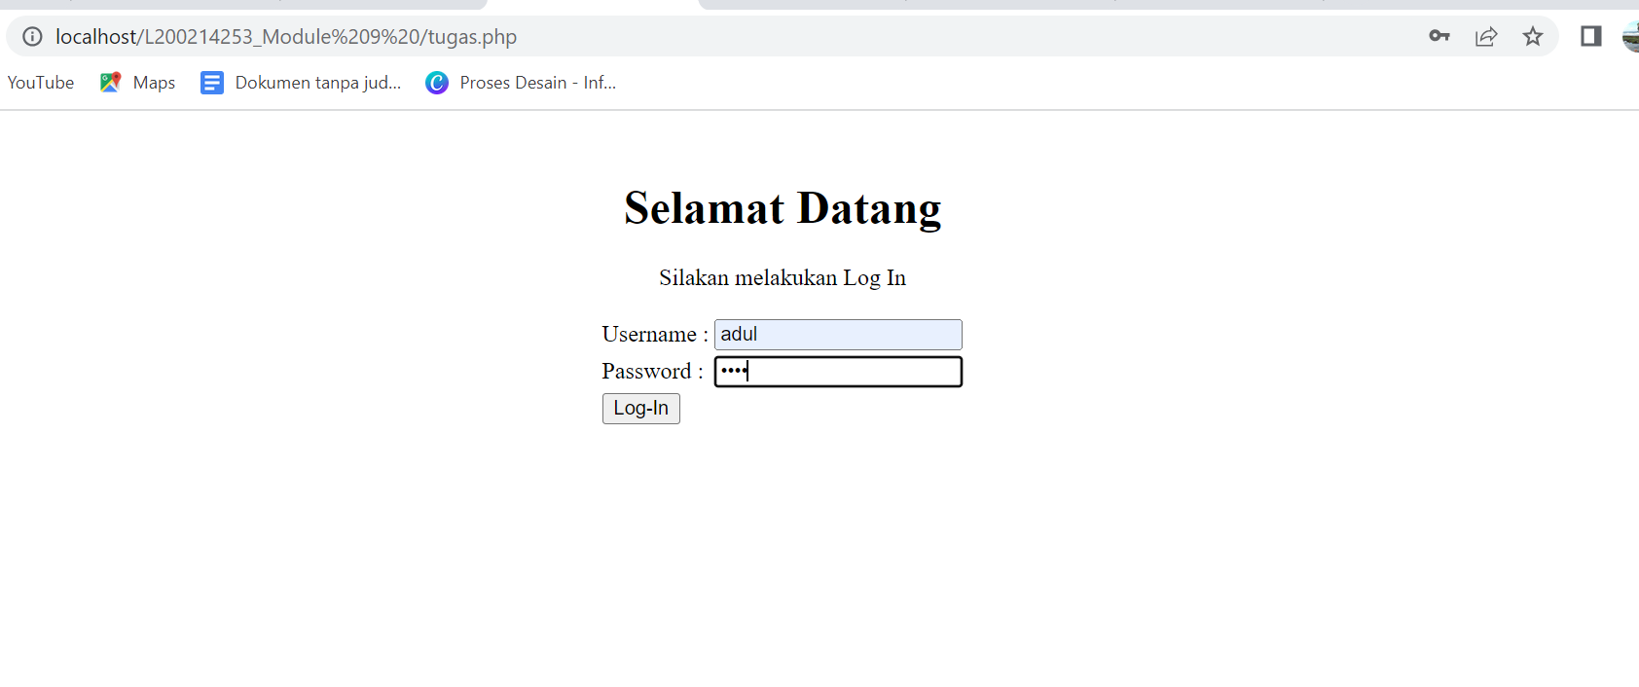

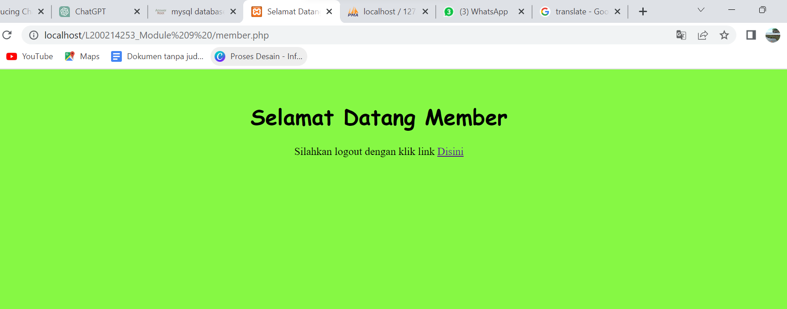

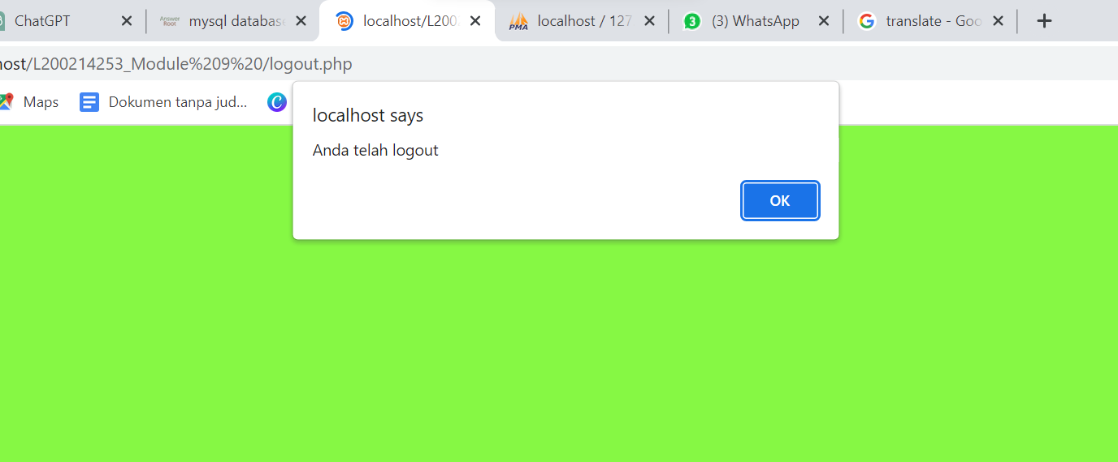

Admin:

